**Assignment-9**

**AI Assisted Problem Solving Using Python –AIAP**

**Student Name:- Guguloth Sai Priya**

**Hall ticket No:- 2505B04204**

**Branch :- Embedded System (ES)**

**Lab 9: Documentation Generation: Automatic documentation and code comments**

**Lab Objectives:**

* To understand the importance of documentation and code comments in software development.
* To explore how AI-assisted coding tools can generate meaningful documentation and inline comments.
* To practice generating function-level and module-level docstrings automatically.
* To evaluate the quality, accuracy, and limitations of AI-generated documentation.
* To develop a small automated tool for documentation generation in Python..

**Lab Outcomes (LOs):**

After completing this lab, students will be able to:

* Apply AI-assisted coding tools to generate docstrings and inline comments for Python code.
* Critically analyze AI-generated documentation for correctness, completeness, and readability.
* Create structured documentation (function-level, module-level) following standard formats.
* Design and implement a mini documentation generator tool to automate code commenting and docstring creation.

**Task Description#1 Basic Docstring Generation**

* Write python function to return sum of even and odd numbers in the given list.
* Incorporate manual docstring in code with Google Style
* Use an AI-assisted tool (e.g., Copilot, Cursor AI) to generate a docstring describing the function.
* Compare the AI-generated docstring with your manually written one.

Expected Outcome#1: Students understand how AI can produce function-level documentation

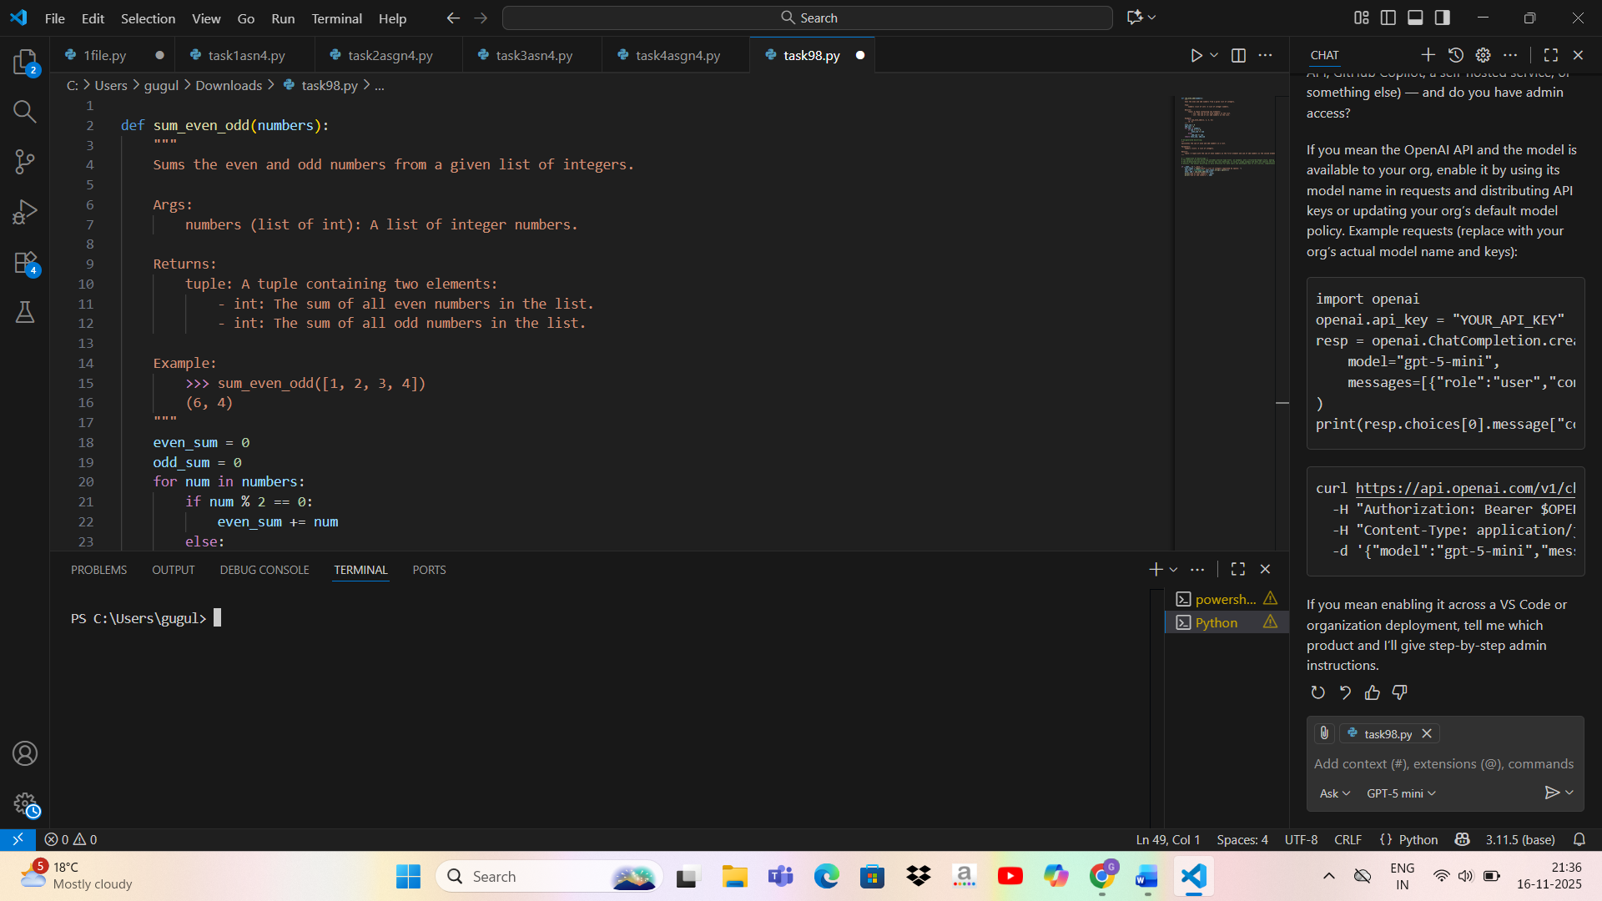

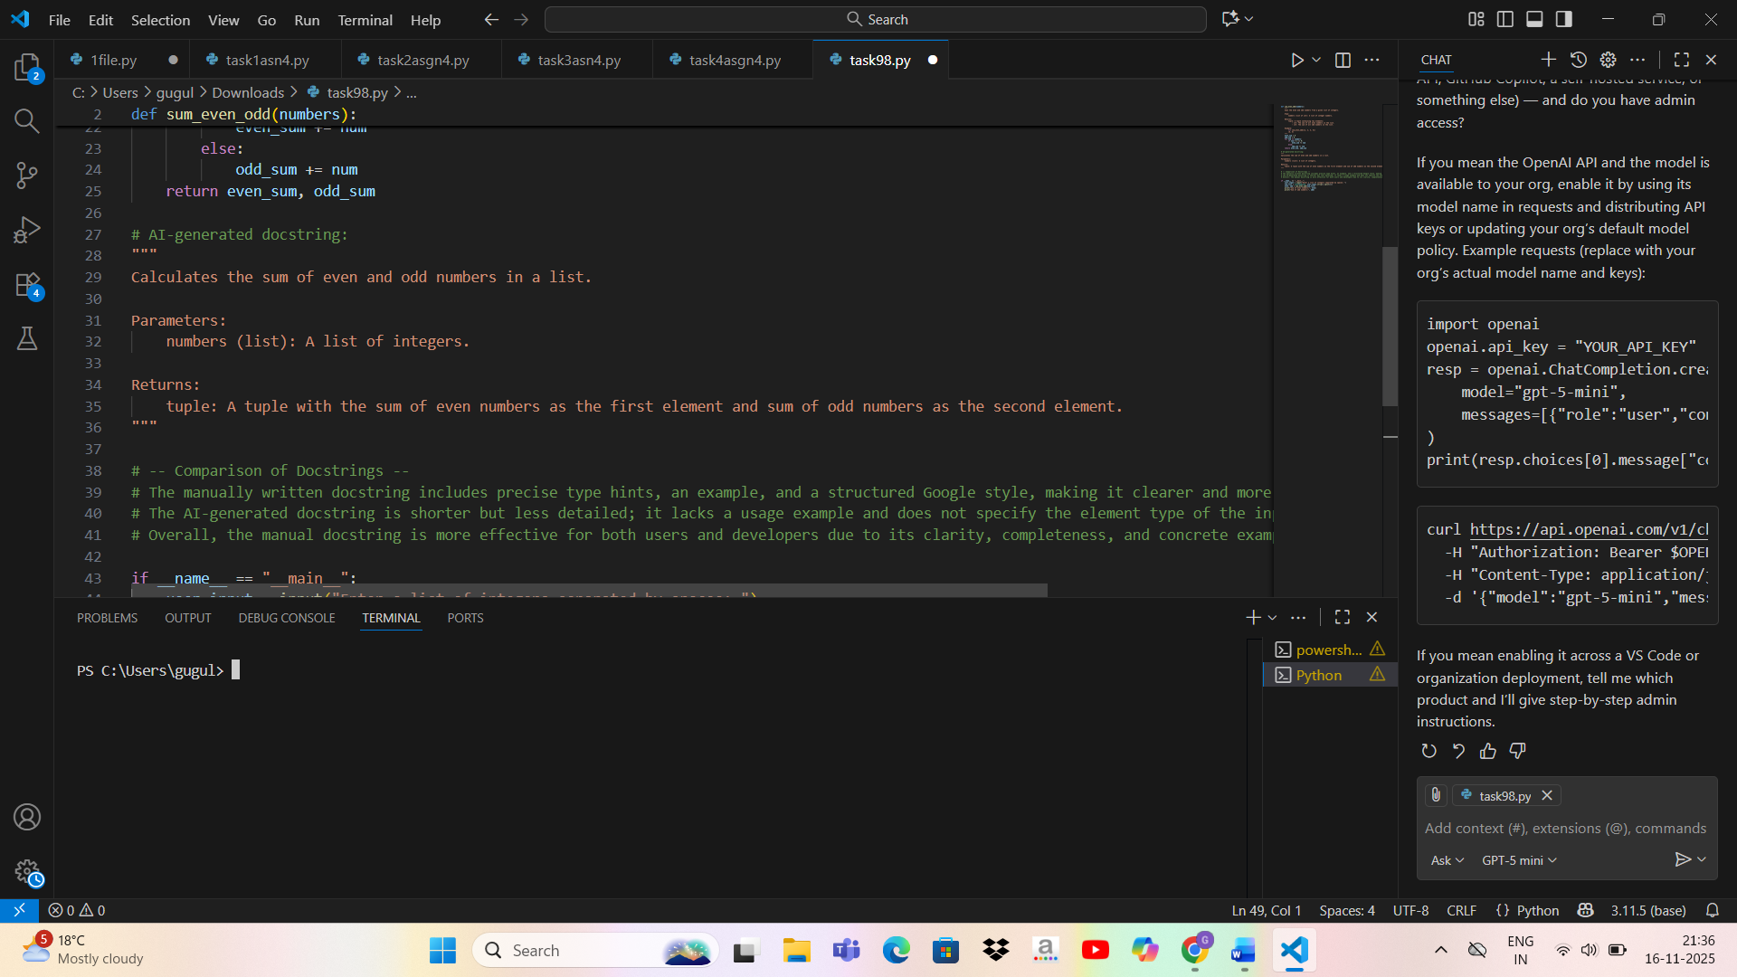

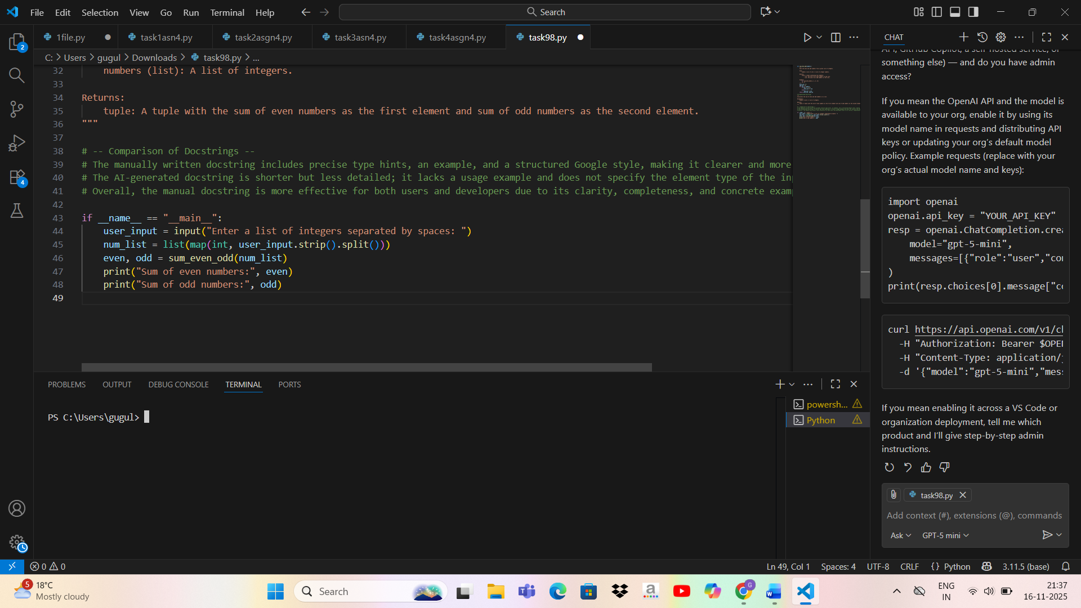

**Task Description#2 Automatic Inline Comments**

* Write python program for **sru_student** class with attributes like name, roll no., hostel_status and **fee_update** method and **display_details** method.
* Write comments manually for each line/code block
* Ask an AI tool to add inline comments explaining each line/step.
* Compare the AI-generated comments with your manually written one.

**Expected Output#2:** Students critically analyze AI-generated code comments

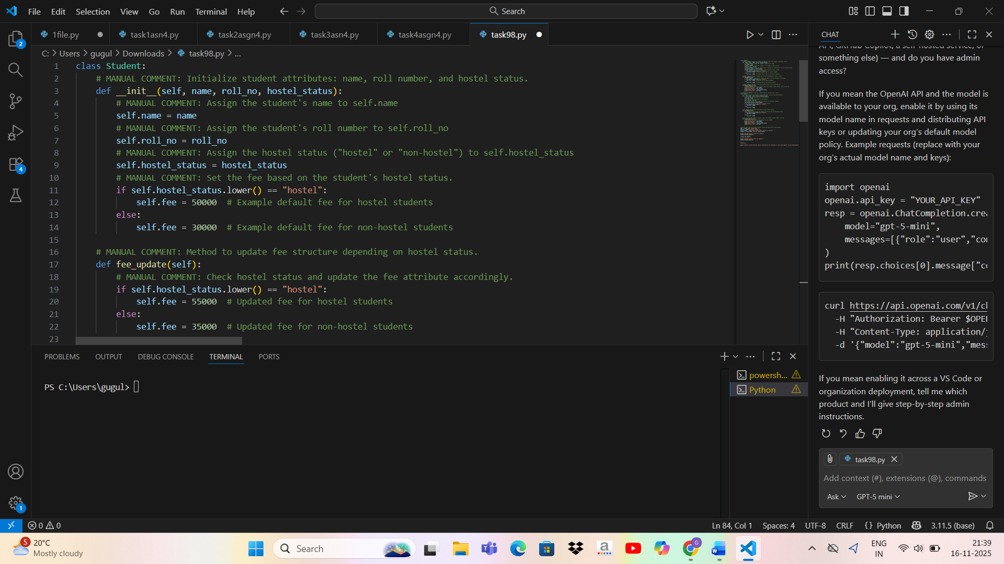

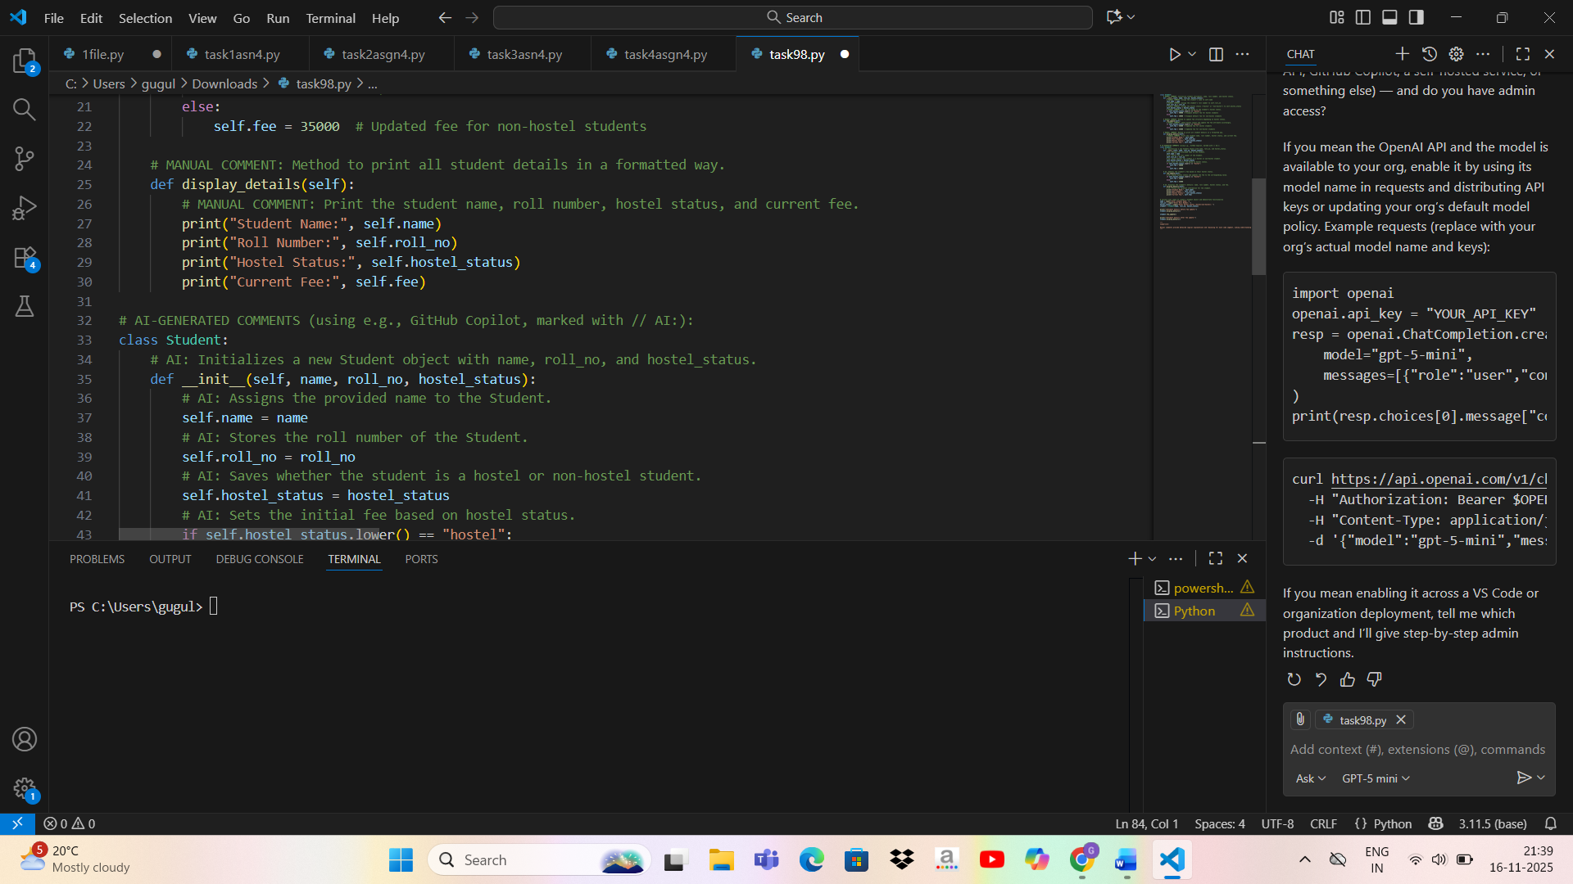

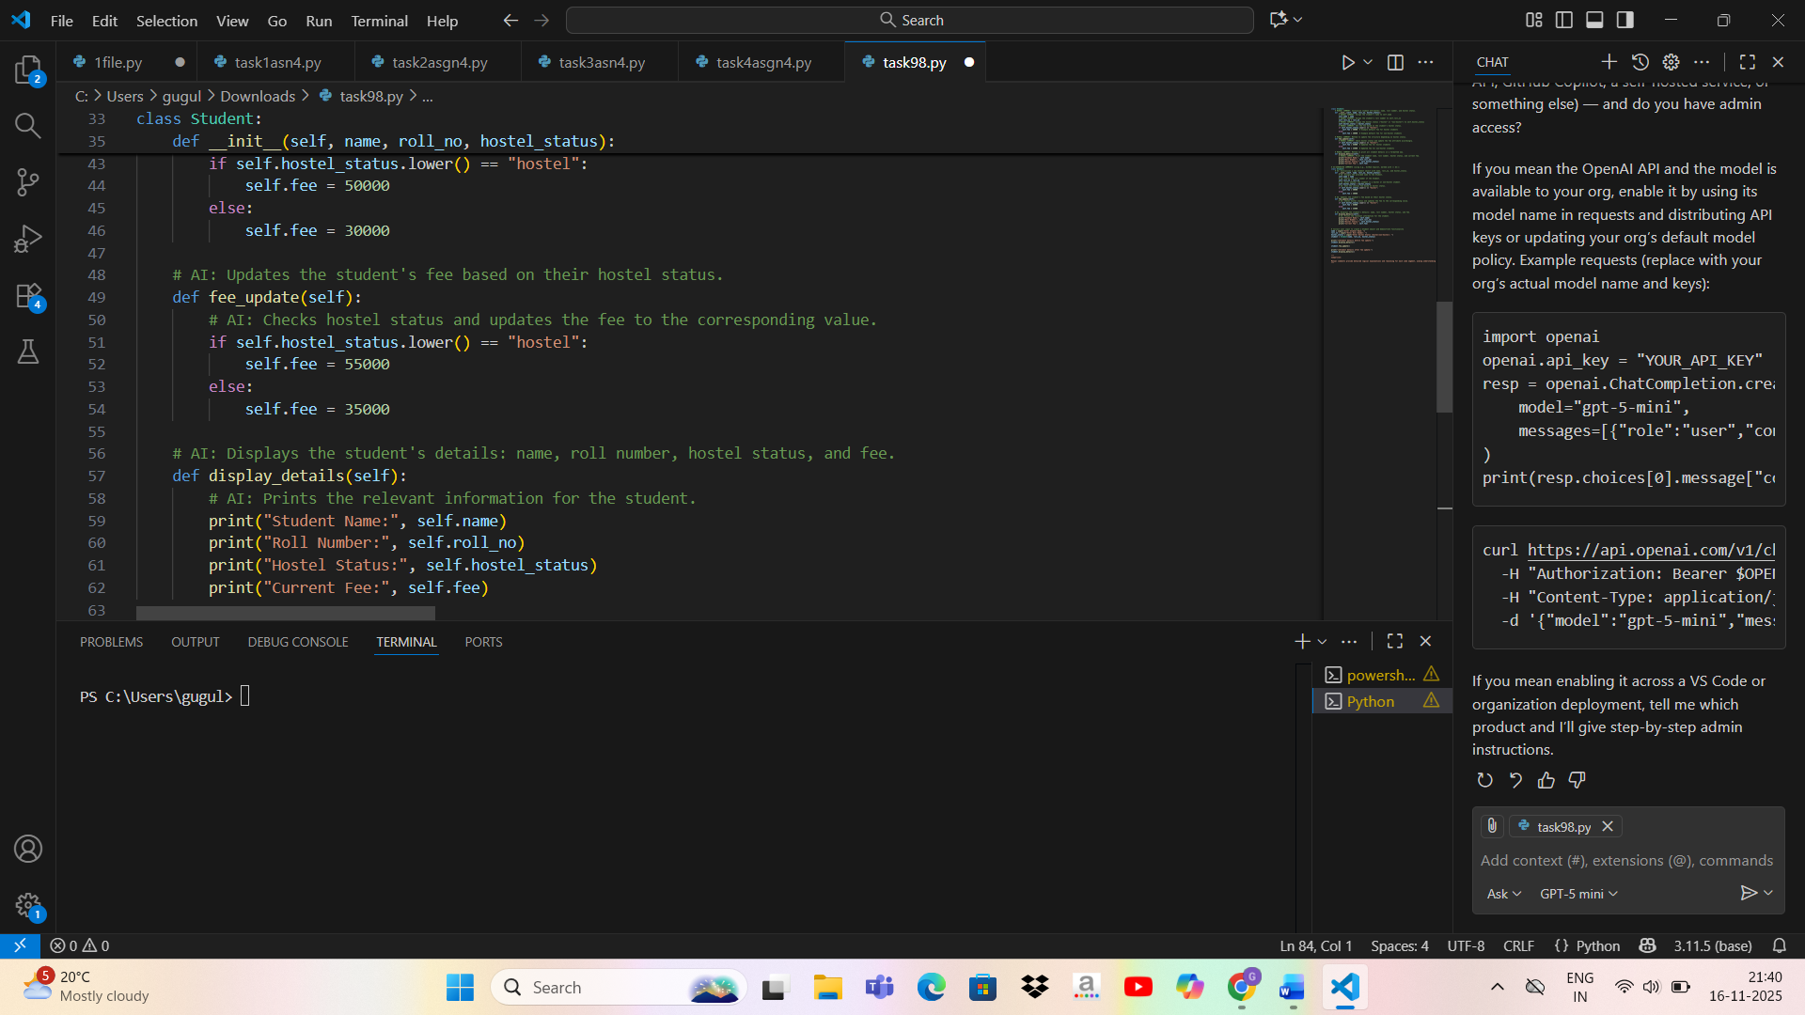

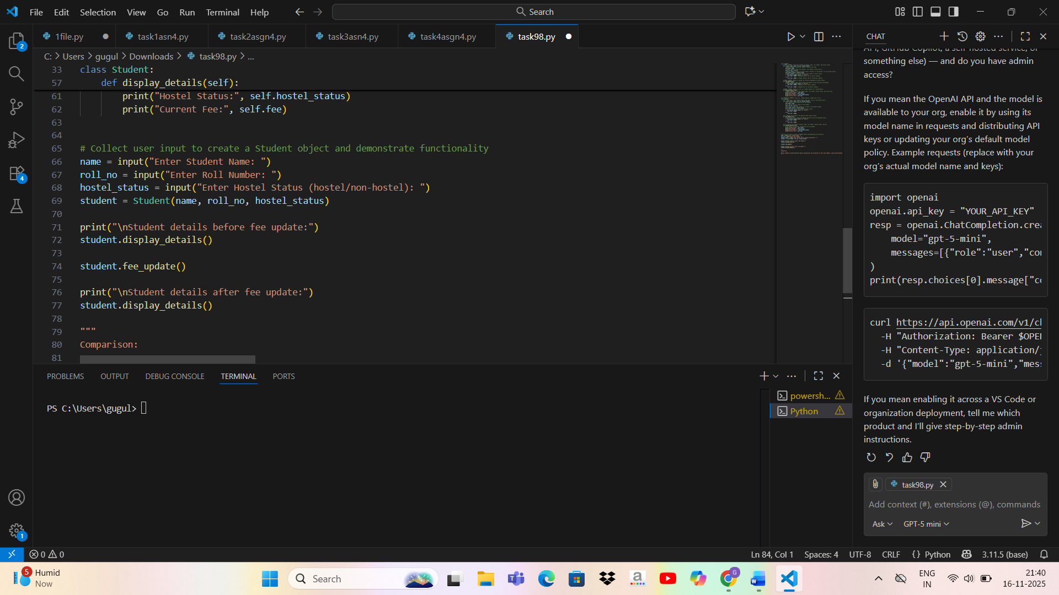

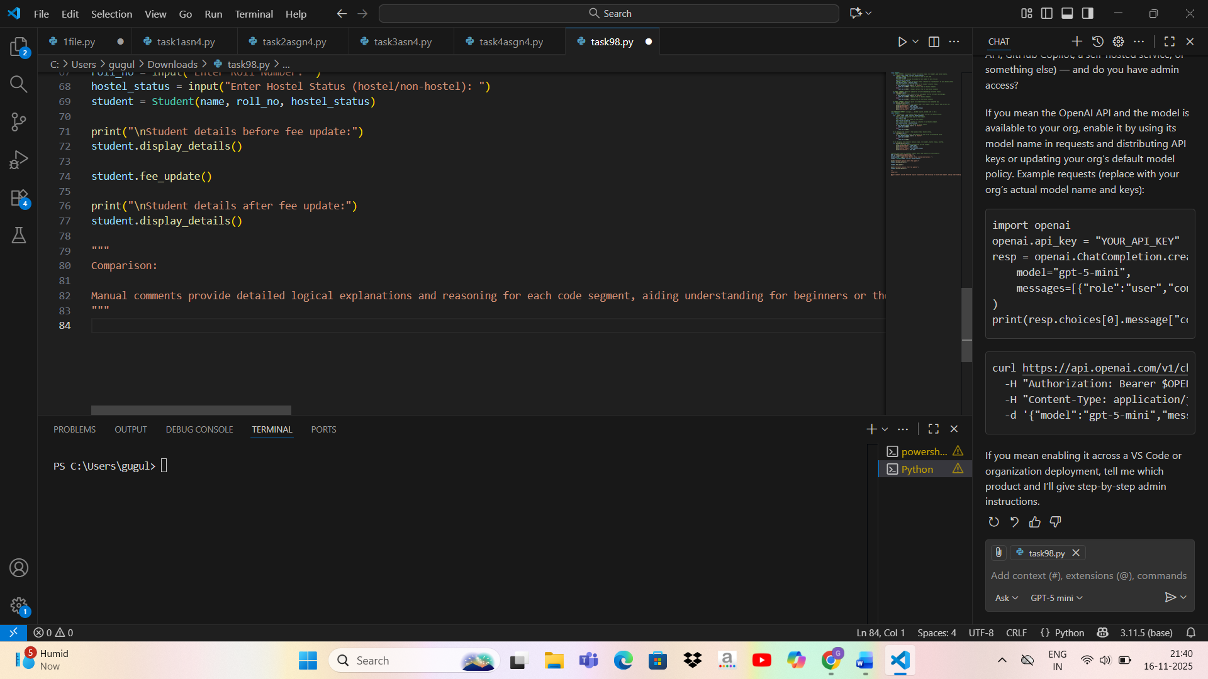

**Task Description#3**

* Write a Python script with 3–4 functions (e.g., calculator: add, subtract, multiply, divide).
* Incorporate manual **docstring** in code with NumPy Style
* Use AI assistance to generate a module-level docstring + individual function docstrings.
* Compare the AI-generated docstring with your manually written one.

**Expected Output#3:** Students learn structured documentation for multi-function scripts

